Econometrics Final project by Akash jajoo

**Fama and French Model used using 3 Factor Model**

Data Used -

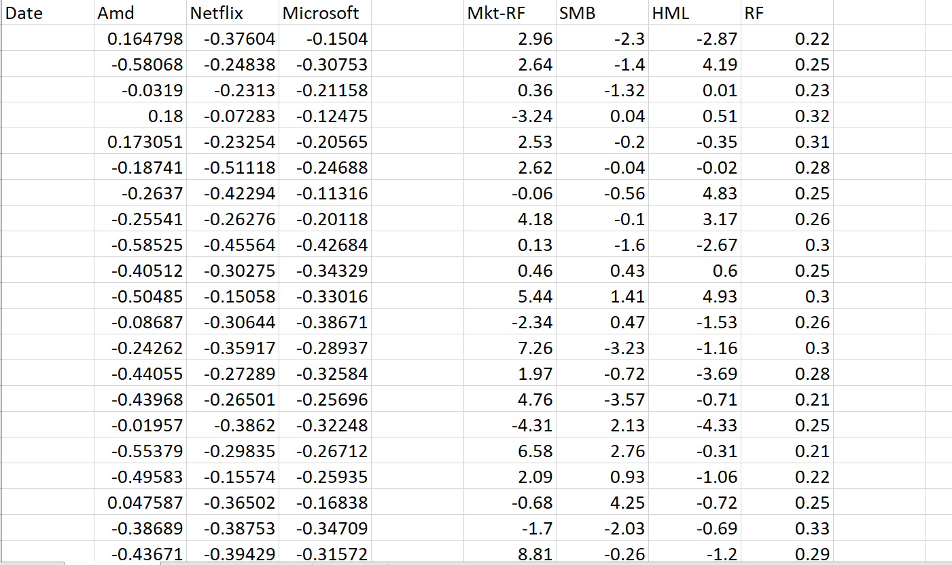

Regression for AMD

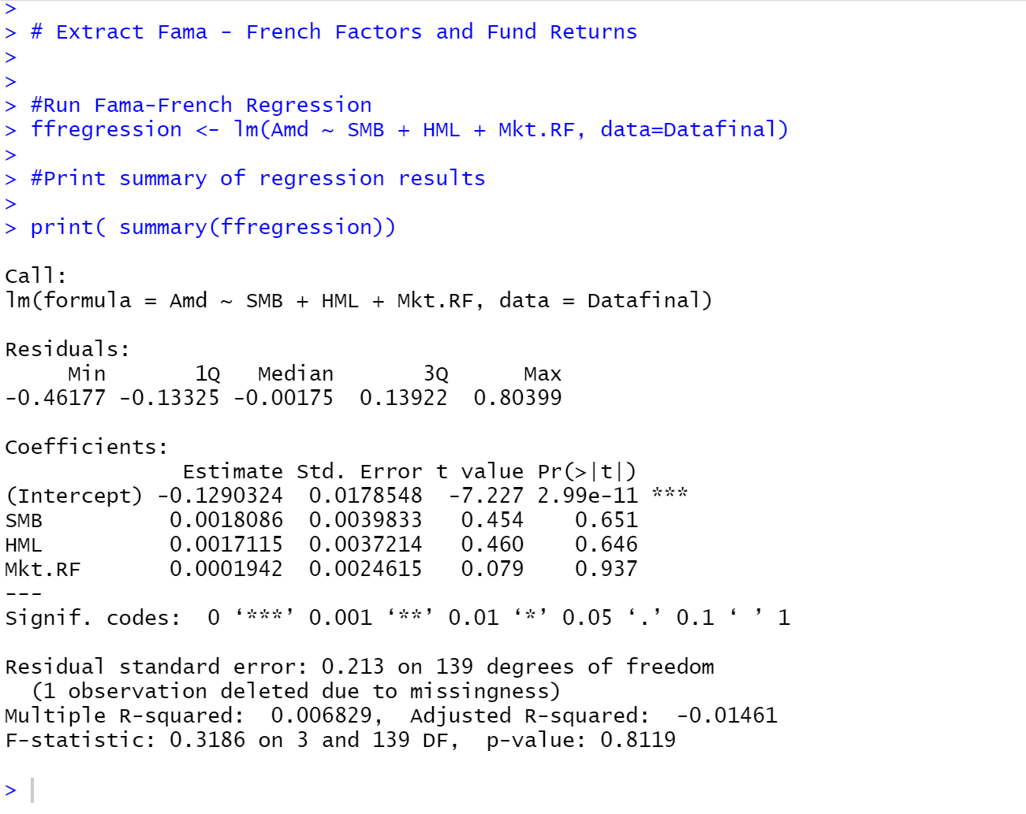

Interpretation of the Regression

**R Square and adjusted R square –** As R Square and adjusted R square tells us the overall accuracy, hence seeing this tells us that our model is not that accurate. As the both of them is around 1.5% – 3%.

**Significance of F of the Regression –** the smaller the significance of F, the greater the probability that the regression output is not by chance in this case the significane of F for the regression is 31.86 which means that there is 31.86% of chance that our output was obtained merely by random chance.

**P-Values of Y-Intercepts and Coefficients –** As smaller the P values, the greater the probability that those outputs were not obtained by chance.

**Residuals shows no Patterns to me**

Regression Analysis on Netflix

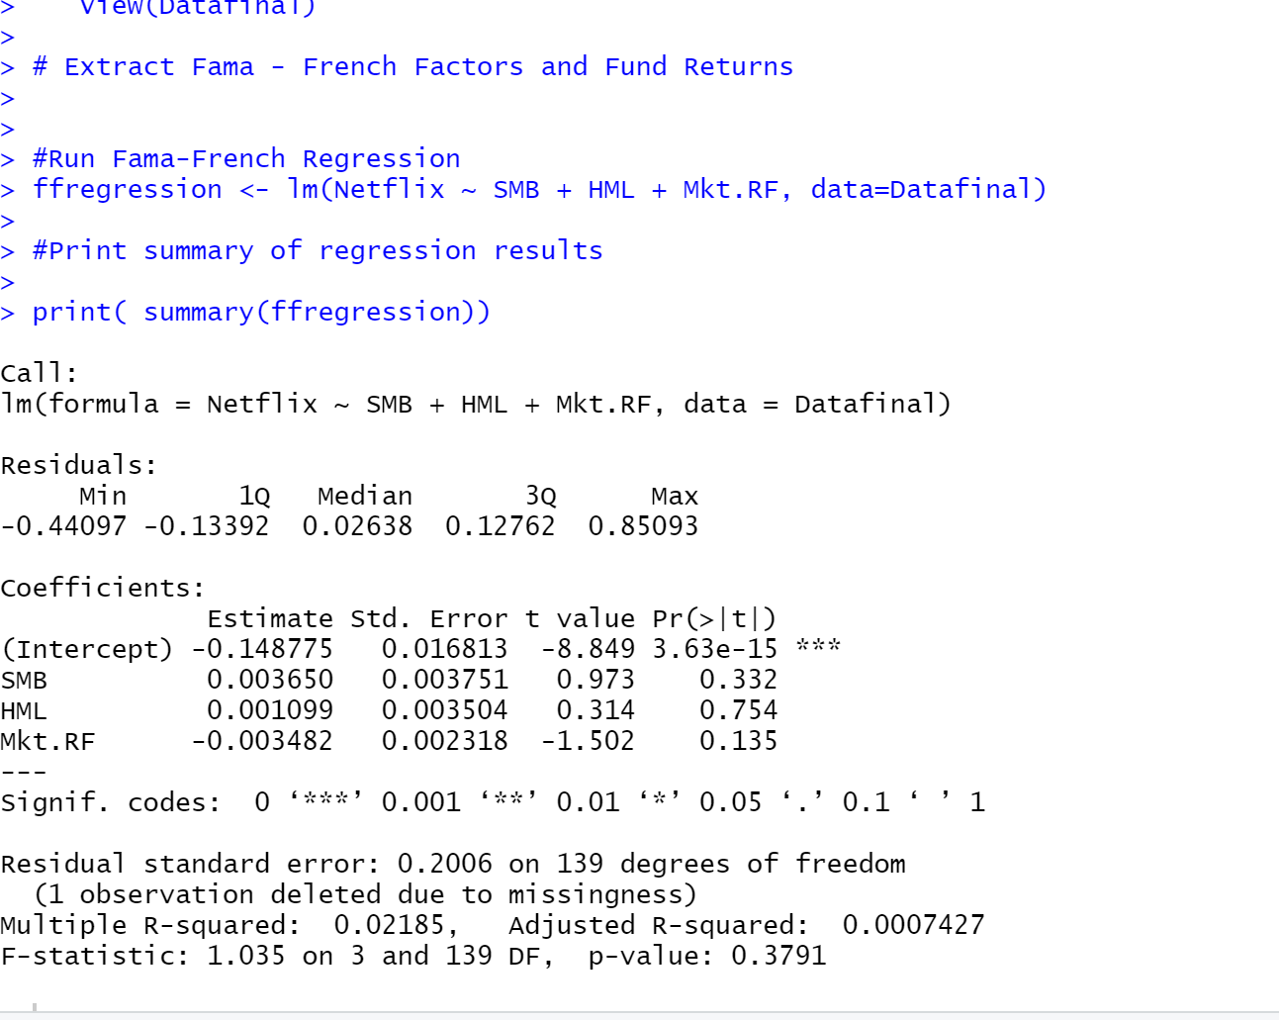

Interpretation of the Regression

**R Square and adjusted R square –** As R Square and adjusted R square tells us the overall accuracy, hence seeing this tells us that our model is accuracy 2.185%.

**Significance of F of the Regression –** the smaller the significance of F, the greater the probability that the regression output is not by chance in this case the significance of F for the regression is 17.76 which means that there is 1.036% of chance that our output was obtained merely by random chance.

**P-Values of Y-Intercepts and Coefficients –** As smaller the P values, the greater the probability that those outputs were not obtained by chance.

**Residuals shows no Patterns to me**

Regression Analysis of Microsoft

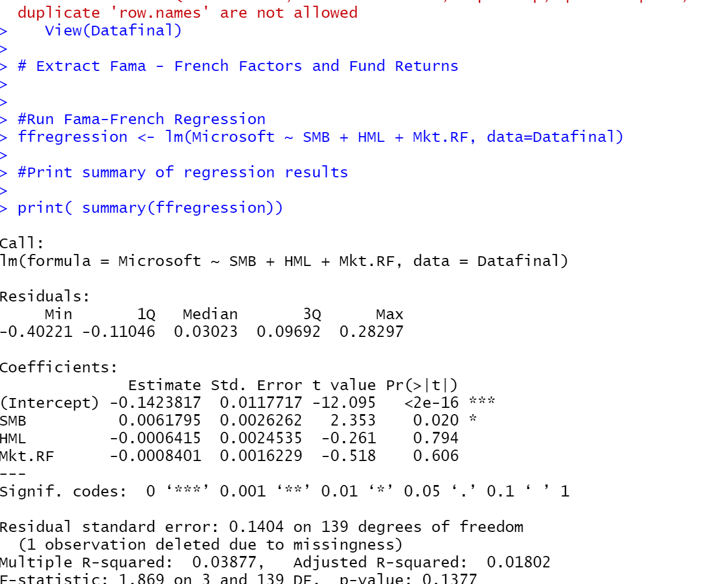

Interpretation of the Regression

**R Square and adjusted R square –** As R Square and adjusted R square tells us the overall accuracy, hence seeing this tells us that our model is Very accurate, as the accuracy is very high. As the both of them is around 3.8%.

**Significance of F of the Regression –** the smaller the significance of F, the greater the probability that the regression output is not by chance in this case the significane of F for the regression is 1.86 which means that there is 1.86% of chance that our output was obtained merely by random chance.

**P-Values of Y-Intercepts and Coefficients –** As smaller the P values, the greater the probability that those outputs were not obtained by chance.

**Residuals shows no Patterns to me**